D12

Version 2024.16

**GSCC**   
Global Supply Chain Concept

Section I:

Global Supply Chain Concept Requirements

Global Supply Chain Concept

– hereinafter referred to as “GSCC” –

by and between

**Legal Entity Supplier**

**Place of Registration / Headquarter**

**Country**

– hereinafter – together with its Related Companies - referred to as "Supplier" –

and

Continental Automotive Technologies GmbH

Continental-Plaza 1

30175 Hannover

Germany

– hereinafter – together with its Related Companies – referred to as "Continental" –

– Supplier and Continental hereinafter referred to alone as "Party” or collectively as “Parties" –.

**Contract date: 25 March 2024**

Preamble

In order to ensure a flexible and demand oriented supply for our global customers, on a basis of economic processes and structures, it is necessary that all suppliers cooperate closely with Continental. Therefore, the suppliers of Continental must meet basic requirements concerning the Supply Chain capabilities.

This GSCC will be valid worldwide for all legal entities within the Automotive Technologies Group Sector of Continental.

With this GSCC the Supplier confirms to comply with Continental’s standard Supply Chain processes as stated within this GSCC and all applicable Technical Standards (“TST”).

This GSCC is divided into two parts:

* Section I (Global Supply Chain Concept Requirements) and
* Section II (Global Supply Chain Concept Complementary Information).

The Supplier acknowledges, that Continental may supplement this GSCC by region or plant specific requirements, in order to respond to specific supply processes of Continental plants or regions.

1. Validity

The latest concluded Strategic Supplier Contract (“SSC”) forms a frame agreement and is the leading contract document for the business relation with the Supplier.

General topics regarding Supply Chain shall be governed by this GSCC. Therefore, this GSCC shall replace or, in case of their subsequent conclusion, take precedence over any and all stipulations and agreements between the Parties concerning general logistic or general Supply Chain requirements (e.g. Logistic Requirements, Supplier Manual Logistic, Global Supply Agreement) and any references thereto in Individual Agreements are to be construed as references to this GSCC.

Without limitation to the foregoing, all other arrangements in existing Individual Agreements between the Parties (e.g. Yearly Pricing and Supply Agreement (“YPSA”), Consignment Stock Agreements (CMI/VMI), Project Agreements) shall not be changed by this GSCC.

Entering into a GSCC is a precondition for Continental’s purchase of Contract Products from Supplier or award of additional business.

2. Definitions

Unless defined in this GSCC, capitalized terms shall have the meaning as set forth in the SSC.

If not set forth otherwise in the SSC, the following shall apply to the GSCC:

The term “Related Company” shall mean any company which, through ownership of voting stock or otherwise, directly or indirectly, is controlled by, under the common control with, or in control of a Party hereto.

The term "control" shall mean with respect to a legal entity, the direct or indirect ownership of more than fifty percent (50%) of the voting interest in such legal entity or the possession otherwise, directly or indirectly, of the power to direct the management or policies of such legal entity.

3. Delivery Reliability

The Suppliers' target is 100% delivery reliability and is defined as delivery in the correct quantity, time, location, packaging, labeling and electronic information of the Contract Product called for by Continental. The delivery reliability is reported through the SupplyOn Performance Monitor to Supplier once per month.

4. Communications

The Supplier shall define and communicate a key contact for Supply Chain issues, as well as a suitable backup, for each Continental location. The Supplier must communicate any changes in contact persons to Continental without undue delay. Each such contact person shall have good language skills in the national language of the respective Continental location or good knowledge of English.

In case of supply shortages (e.g. during allocation) an emergency contact shall be established by Supplier, to ensure 24/7 attainability, just in case the key contact and its backup are not reachable. The emergency contact and required response time may be aligned individually between the Supplier and the Continental production locations.

5. Electronic Data Interchange (“EDI”)

The Supplier accepts that EDI standard (e.g. EDIFACT, VDA) is used for all necessary data exchange. Continental will also accept the alternative process of WEB EDI (via SupplyOn).

The Supplier agrees to install upon Continental’s request EDI or WEB EDI connections for the following message types for the communication between the Parties:

* Delivery Schedule
* Inventory Report
* Invoices / Self-Billing Invoices (“SBI”) for Evaluated Receipt Settlement system in consignment stock
* Advanced Shipping Notification (“ASN”) / Delivery and Transport Data / Planned Deliveries (DELFORP).

Each Party shall bear its own costs arising out of the establishment, maintenance and use of the communication mode including any fees relating to the use.

The Parties must check, if the received messages are complete, correct and plausible. If any deviations are noted, the respective Party must inform the responsible Continental or Supplier contact without undue delay.

6. Preferred Sourcing Models (“PSM”)

The Supplier is requested to deliver the Contract Products according to one of the following PSM:

* Customer Managed Inventory (“CMI”) consignment warehouse
* Vendor Managed Inventory (“VMI”) consignment warehouse
* Just-in-Time (“JIT”).

The respective PSM shall be chosen by the individual Continental location in alignment with Supplier. Both Parties shall bear their own costs arising from the implementation and operation of the PSM.   
For establishment of a CMI or VMI consignment warehouse, the Parties are obliged to sign an Individual Agreement. Supplier shall provide proactive support in implementation and utilization of the PSM.

7. Order Management and Flexibility

Depending on the agreed sourcing model, the Supplier receives Delivery Schedules (for CMI/JIT/STS) or gross demand information (for VMI), which updates Continental’s demand (rolling forecast) for minimum twelve (12) months. A new valid Delivery Schedule or gross demand information replaces the previous one completely, whereat the stipulations of article 7.2 do apply.

7.1 Supply Flexibility

The Supplier shall provide flexibility of ± 20% of the cumulated quantities within the series lead-time in accordance with the latest rolling forecast and without any costs for Continental. The series lead-time shall be mutually agreed between the Parties, e.g. in the course of the Supplier Component Review (SCR) or in a subsequent Individual Agreement. To ensure this flexibility, the Supplier may use existing consignment inventory at Continental location.

Without limitation to the foregoing, the Delivery Schedules (CMI/STS) or gross demand information (VMI) are deemed to be accepted and approved by Supplier, unless a written notification of delay is received by Continental within two (2) working days after receipt of latest Delivery Schedules or gross demand information by Supplier. In case of notification of delay, Supplier shall provide Continental a detailed recovery or action plan within five (5) working days after receipt of the concerned Delivery Schedule or gross demand information.

7.2 Frozen Window (except for JIT and VMI)

“Frozen window” shall mean that the quantity and delivery dates are fixed in the respective Delivery Schedule and can only be changed in mutual agreement between Continental and the Supplier.  
In order to align the material flow to automotive requirements, Continental allows a frozen window (fixed horizon) covering the transport time from the last shipping point of the Supplier for Contract Products supplied to Continental.

7.3 Missing or Implausible Rolling Forecast

In the event Supplier does not receive updated Delivery Schedules or gross demand information within the defined cycles or updated Delivery Schedules or gross demand information are implausible, the Supplier must inform Continental without undue delay. Both Parties shall then mutually agree on the further proceeding.

7.4 Production Capacity

In order to ensure the supply of Contract Products, the Supplier must assure sufficient capacity according to the YPSA or, in case no YPSA exists, an other Individual Agreement (e.g. Project Agreement). Supplier must compare regularly the requested demand according to the Delivery Schedule or gross demand information with available and contracted capacity. Supplier shall immediately communicate any lack of capacity to the ordering Continental location and the responsible Continental purchaser.

8. Logistics Evaluation New Platform (MMOG/LE NP)

The Material Management Operations Guideline / Logistic Evaluation (MMOG/LE) is the standard for evaluating supply chain processes in the automotive industry. It is a tool that enables a comprehensive self-evaluation, and which is used by all OEM’s and their suppliers for internal assessments, organization benchmarking, and improving supply chain performance.

Continental requires MMOG/LE NP v5 full version. Send your MMOG file, if not agreed otherwise, in XML format to the following address: mmogle@continental-corporation.com.

9. Supplier Capacity Update (“SCU”)

The SCU is a process in which business partners consult each other with the aim to detect and avoid Supply Chain problems at an early stage, in the event it is foreseeable that the updated quantities in the Delivery Schedule or gross demand information exceeds the planned volume plus the agreed additional production capacities.

For SCU, the Supplier must check its capacity (including availability of production equipment, semi-finished components, supply of raw materials by sub-suppliers) and confirm the realizable supply of the demand per part number and per Continental location upon Continental’s request.

In the event of negative capacity feedback, the Supplier and Continental will work closely together to evaluate and implement an appropriate solution.

10. Allocation Management

The Supplier agrees to cooperate with Continental in all risk management actions, especially for avoidance of allocation situations.

If a material shortage is foreseeable, and might affect the supply of Continental, Supplier is obliged to

1. give prior written notice to the respective Purchasing and Supply Chain departments of Continental and
2. initiate countermeasures without undue delay.

In the event more than one Continental location is concerned, the Supplier is obliged to install a worldwide manager, who will coordinate the distribution of available amounts of the Contract Products with the respective allocation manager at Continental.

The Supplier is obliged to support Continental in data maintenance of an allocation tool, in order to support an efficient allocation process. The Supplier undertakes all efforts to resolve the shortage situation as soon as possible.

In case of emergency delivery, the Supplier must provide all available details of the transport to ensure full transparency (e.g. means of transport, transport route, estimated time of arrival).

11. Transportation, Customs/ Foreign Trade and Export Control

Definition, process and requirements are specified in Continental´s TST N09800.02-000 “Transportation, Customs / Foreign Trade and Export Control”.

11.1 Transportation

For all shipments, the Supplier shall comply with any and all applicable national and international rules, laws, regulations and requirements.

Supplier shall hand over the shipments to the nominated forwarder for the trade lane and transport mode according to the respective delivery term agreed upon in the Individual Agreements.

Responsibility of Supplier for, inter alia, transportation costs, insurance and customs risks shall be based on the agreed INCOTERMS or Continental Automotive Trade Terms.

The Supplier understands that it is in his responsibility to ensure that the Contract Products arrive at the respective Continental location in time or, depending on the chosen delivery term, are ready for pick-up in time.

In general, Continental requests the Supplier to deliver according to following preferred delivery terms:

* DDP (INCOTERMS 2020)
* DAP (INCOTERMS 2020)
* CA-DAP (Continental Automotive Trade Term, TST N09800.02-001)
* CA-DDP (Continental Automotive Trade Term, TST N09800.02-001)

In order to meet the requested arrival date, the Supplier shall calculate the date of the planned pick-up of the Contract Products considering the transit time.

The Supplier shall ensure the correctness and completeness of all shipping documents according to national / international legal standards, customs requirements and required information of Continental. The data on the shipping documents shall match the data sent by supplier (e.g. ASN) and the advance export customs declaration, if such customs declaration is applicable.

The Supplier shall attach the full set of transportation documents (e.g. shipping order, picking list, bill of lading, proforma invoice) and quantity of copies defined by the dedicated forwarder to the respective shipment.

11.2 Alternative transportation methods

In the event that a time-saving alternative transportation (e.g. premium flights, hand carry (OBC), next flight out (NFO)) becomes reasonably necessary, as in comparison to the agreed standard transportation, it shall be organized by the Supplier in its own name.

The costs therefore shall be (i) for the account of the Supplier or (ii) mutually agreed between the Parties in advance, if the alternative transportation is at the instigation of Continental without any fault on the part of the Supplier (e.g. delivery delay). For subsequent customs clearance it is required to involve the responsible customs department in the receiving country.

Without limitation to the foregoing, Continental reserves the right to support the Supplier in organization of a faster transportation and to demand and/or suggest alternative solutions (e.g. in case the alternative is more cost-effective).

11.3 Transport Management System (TMS)

In case Continental is using a TMS system and the forwarder is contracted by Continental, the Supplier shall notify the forwarder that products are ready for dispatch by TMS platform with all relevant transport information. The time window for the pick-up shall be agreed between the Supplier and the forwarder.

If TMS of Continental is not implemented, the way of notification should be mutually agreed between the Supplier and the selected / defined forwarder and, if in place, the shipment advice tool of the forwarder shall be used. TMS is not required for the delivery terms DAP and DDP.

11.4 Customs / Foreign Trade

The Supplier shall at all times comply with all applicable laws, rules, regulations, free trade agreements of the country(ies) of origin, transportation and destination.

The Supplier shall be responsible according to the delivery terms for all customs or other governmental requirements with regard to, inter alia, import rules, classification, valuation, preferential treatment and duty drawback.

Furthermore, Supplier shall provide Continental timely notice of any noncompliance related to customs and foreign trade.

The Supplier shall cooperate with Continental and take all actions necessary, in Continental's sole discretion, to remedy any such noncompliance.

11.5 Export Control

The Supplier shall comply with any and all applicable export control laws and regulations applicable to the Contract Product, including without limitation, sanctions, embargoes and other laws, regulations, government orders and policies controlling the transmission or shipment of Contract Products and technology.

12. Labeling of Contracted Products

The Supplier agrees to label all packaging units in accordance with Continental´s TST N09800.03-000 “Requirements on marking of goods”. Label position is defined specifically on Continental production location level.

If not agreed otherwise, the Supplier shall apply the following 2D label types according to the request of the receiving Continental location:

* MAT-Label
* PDF417-Label

Only in exceptional cases upon express approval by the respective Continental location the following 1D-label type may be accepted:

* Automotive standard label according to e.g. VDA-, GALIA-, AIAG-, ODETTE standards

Upon request, the delivery note has to contain a 2D-Code described in the respective specifications.

Any deviations shall be agreed mutually between the Supplier and the ordering Continental location.

13. Packaging Requirements

Definition, process, and requirements to packaging (e.g. expendable or returnable) are specified in Continental´s TST N09800.01-000 “Packaging Requirements for CA Plants and Suppliers worldwide” and accompanying documents.

Both Parties shall mutually agree on a Packaging Specification Data Sheet (PSDS) according to TST N09801.01-000 in the course of the Supplier Component Review (SCR). In the event no SCR takes place, Supplier shall agree on a PSDS with each ordering Continental location before start of delivery. In case of any necessary changes, the PSDS needs to be aligned and mutually agreed again prior to the Production Part Approval Process (“PPAP”). The PSDS must be available for the PPAP.

The Supplier agrees to deliver the Contract Products according to the agreed packaging specification and all applicable legal regulations. Any deviation needs an upfront written confirmation from the concerned Continental location.

In order to avoid supply issues because of missing returnable packaging, to the extend such returnable packaging is used, an alternative or substitute packaging concept shall be agreed within the PSDS, too.

All Contract Products are to be prepared, packed and marked suitable for shipment to secure safe delivery, to avoid deterioration, to ensure delivery free of defects upon arrival and to meet all safety, environmental and legal requirements.

The approval of the packaging by Continental does not relieve the Supplier from its responsibility to supply the products in agreed quality.

14. Liability for Non-conformities

In the event of non-conformities related to Supply Chain issues, Continental reserves the right to charge all documented costs incurred in connection with such non-conformities to the Supplier.

15. Compliance

If not set forth otherwise in the latest SSC or YPSA, by signature of this GSCC, the Supplier confirms to comply with the Business Partner Code of Conduct of Continental.

The document can be provided to the Supplier by Continental upon request.

16. Miscellaneous

16.1 Severability Clause

If any terms of this GSCC are, or should become entirely or partially invalid or unenforceable, this shall not affect the validity of the remaining provisions. The foregoing shall also apply if this GSCC contains any regulatory gap. Instead of the invalid or unfeasible provision, or in order to close the gap, a ruling shall be used, which, in so far as it is legally permissible, as closely as possible reflects the intentions of the Parties concluding this GSCC or, considering the meaning and purpose of this GSCC, the potential intentions the Parties had when they considered the point at the time of concluding this GSCC.

16.2 Written Form

No modification to, amendment of, or waiver of any provision of this GSCC will be binding, unless made in writing signed by both Parties. Any waiver of this requirement must be in writing. For avoidance of doubt, communication in e-mails shall not qualify as written notice.

16.3 Governing Law

This GSCC shall be governed, construed and enforced in accordance with the laws of Germany. The United Nations Convention on Contracts for the International Sale of Goods of April 11, 1980 shall be excluded.

16.4 Place of Jurisdiction

The exclusive place of jurisdiction for all disputes arising out of or in connection with the GSCC or any related agreement shall be Frankfurt/Main, Germany. Supplier agrees that it will continue to perform its obligations under this GSCC during any dispute between the Parties.

17. Term

This GSCC shall become effective upon signature by Continental and the Supplier.

This GSCC shall remain in effect until either

a) expressly terminated by either Party upon serving the other Party a six(6) month's written noticeto the end of the calendar year or

b) by conclusion of a new general Supply Chain agreement between the Supplier and Continental which expressly replaces this GSCC.

For the avoidance of doubt, a termination of this GSCC shall not have any impact on the validity and enforceability of any other Individual Agreement.

18. Global Supply Chain Concept Complementary Information

The Supplier confirms that he has read, understood and agrees to the Global Supply Chain Concept Complementary Information (Section II).

Place, Date: Place, Date:

**Continental Automotive Technologies GmbH Supplier legal entity (Headquarter)**

_____________________________ _____________________________

name: name:  
function: function:

Place, Date: Place, Date:

**Continental Automotive Technologies GmbH Supplier legal entity (Headquarter)**

_____________________________ _____________________________

name: name:  
function: function:

Section II:

Global Supply Chain Concept Complementary Information

Content

Chapter 1: Introduction 4

1.1 Scope 4

1.2 Source of information 4

Chapter 2: Information and Communication 5

2.1 Contacts and EDI Information 5

2.1.1 Supplier Contacts 5

2.2 Exchange of Data and Business Communication 5

2.2.1 EDI with Continental 5

2.2.2 Setting up an EDI connection with Supplier 6

2.2.3 Monitoring and EDI Processing 7

2.3 EDI Supported Business Communication and Message Types 7

2.3.1 Delivery Schedule 7

2.3.2 JIT Schedule 7

2.3.3 Inventory Report 7

2.3.4 Self-Billing Invoices (SBI) 8

2.3.5 ASN - Advanced Shipping Notification -, ‘Global ASN’ and Delivery and Transport Data 8

2.3.6 DELFORP (Delivery Forecast Planned) 8

2.4 WEB EDI via SupplyOn 8

Chapter 3: Preferred Sourcing Models (PSM) 9

3.1 CMI - Customer Managed Inventory consignment warehouse 9

3.2 VMI - Vendor Managed Inventory Consignment Warehouse 10

3.3 JIT - Just in Time 11

Chapter 4: Order Management and Planning 11

4.1 Delivery Schedule Processing 12

4.2 Delivery Schedule Types 12

4.2.1 Delivery Schedules – Differences in Sourcing Models 12

Chapter 5: Supply Chain non-conformities 13

Chapter 6: SCM Evaluation Processes 14

6.1 Supplier Evaluation at Continental 14

6.2 SCM Supplier Evaluation Criteria 15

6.2.1 Delivery Capability 15

6.2.2 PSM Rate 17

6.2.3 Supply Chain Complaints 17

6.2.4 Self-Assessment (MMOG/LE NP) of SCM Processes 17

6.3 Supplier Evaluation Reporting 18

6.3.1 Availability of Data 18

6.3.2 How to work with SupplyOn Performance Monitor 18

6.3.3 Summary of the Supplier Performance Evaluation (in SupplyOn designated as Overview) 18

6.3.4 Monthly SCM Performance (in SupplyOn designated as Operational Evaluation Supply Chain) 19

6.3.5 BASE for strategic suppliers (designated in SupplyOn as Strategic Evaluation) 19

Frequently used Definitions and Abbreviations 20

# Chapter 1: Introduction

## 1.1 Scope

The **Global Supply Chain Concept** applies to all suppliers of Continental supplying approved raw material, production material or Contract Products.

Processes during prototyping, pilot build, initial samples build-up and Supply Chain processes for product termination or aftermarket requirements might be, if not regulated in Individual Agreements, handled on a case-by-case basis in close alignment with the ordering Continental location.

The clauses in this Section II comprise background information and Continental internal process descriptions that have to be acknowledged. Dependent on the mutually agreed stipulations in Section I, not all elements of Section II may apply for the individual business relationship between the Parties, but may become applicable after Individual Agreement.

## 1.2 Source of information

The applicable Technical Standards (“TST”), as well as additional information on Continental Supply Chain processes, in the latest released version, can be found on the Internet at following link:

https://www.continental-automotive.com/en-gl/Passenger-Cars/Company/Supplier-Information/Supplier-Logistics

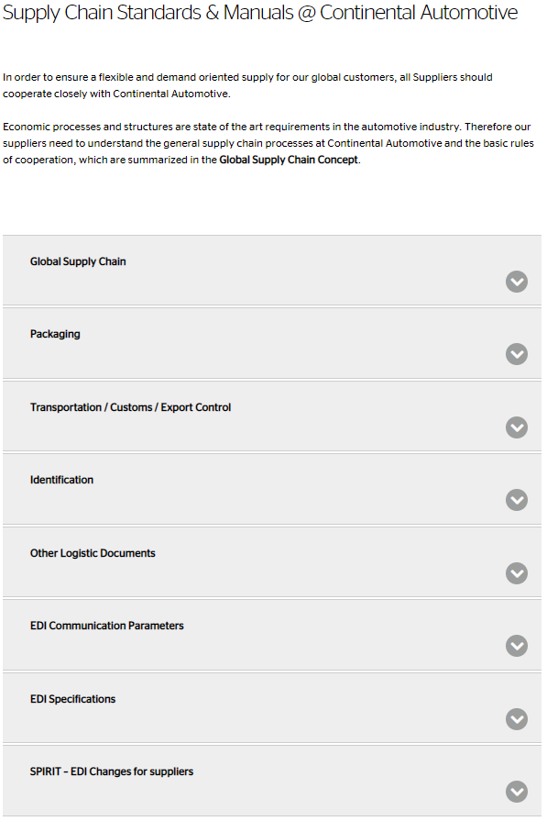

Figure 1: Screenshot from internet webpage

# Chapter 2: Information and Communication

## 2.1 Contacts and EDI Information

### 2.1.1 Supplier Contacts

The basis for successful cooperation between business partners is communication. Information sharing, which is automated to the greatest extent possible, is as important as having the designated key contacts available when needed.

This allows Continental to address quickly any problems to the responsible contact whenever necessary.

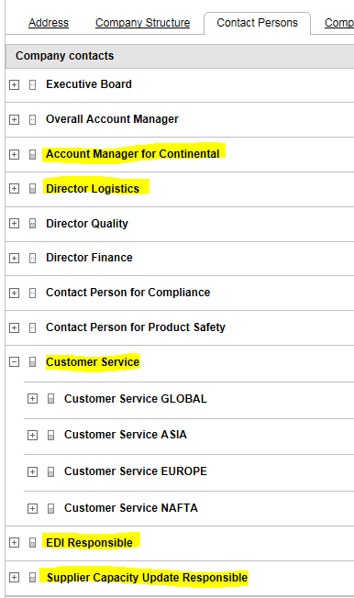Continental decided to use the **SupplyOn Business Directory** as a sustainable data source for key contacts to our suppliers to provide and request group-oriented information.

Following key contacts for Supply Chain must be maintained and hold up-to-date:

* Account Manager for Continental
* Director Logistics
* Customer Service (incl. 24/7 Hotline Phone Number)
* EDI Responsible
* Supplier Capacity Update Responsible

Figure 2: Maintenance Contact Persons in SupplyOn

2.1.2 Continental Supply Chain Management Contacts

Within Continental there are different SCM contacts for various topics. In day-to-day operations, the contact for Supplier is a respective SCM contact at the ordering Continental location. This includes for example topics related to material management, EDI implementation, material shortages only affecting one Continental plant. However, Continental Business Area SCM or Continental A O SCM handle strategic topics on a global level (e.g. allocation affecting more than one plant).

## 2.2 Exchange of Data and Business Communication

Harmonization of its IT-Systems is Continental's long-term strategy. This includes the migration of as many suppliers as possible to a data exchange via EDI by covering the full set of standard business communication with Supplier by EDI (e.g. Delivery Schedule, Shipping Notification, Self-Billing Invoice). For this reason, this section describes the general EDI processes and the process of setting up an EDI communication with Continental.

### 2.2.1 EDI with Continental

EDI replicates paper-based business communication (e.g. Delivery Schedule, Advanced Shipping Notification or Invoices) to a strictly formatted message, that is exchanged electronically between the IT-Systems of Continental and Supplier. The exchanged data and information are formatted according to mutually predefined standards.

The implementation of EDI benefits both Supplier and Continental, because it reduces manual handling of data, transfers information faster, enhances data accuracy and automates routine transactions.

However, it is not possible to process EDI messages directly between IT-Systems. Continental's ERP-System sends EDI messages in SAP IDoc format to an EDI subsystem, where these messages are converted to a universal EDI standard (e.g. UN/EDIFACT). The EDI subsystem administrates all outgoing and incoming messages, provides a gateway to external partners and enables communication with non-SAP systems. Supplier’s IT-System can be connected to the IT-Systems of Continental via protocols (e.g. TCP or EDI special protocols (like OFTP, OFTP2, AS2, and VAN) or via private networks (e.g. GXS). A specific syntax is necessary, so that incoming or outgoing data is processed correctly.

IT-Systems and message standards are customized to Continental's locations requirements. This leads to a variety of different EDI standards and message formats that are currently used at Continental. However, Continental's long-term strategy is to harmonize existing EDI connections with suppliers. Therefore, Continental developed company specific formats for each message type with its syntax (data element, segment and EDI envelope) based on one global EDI standard (EDIFACT or VDA). New EDI connections will be set-up according to this standard, and existing EDI connections are migrated towards one global EDI standard according to the messages type. In justified cases, and if the Continental production location agrees, alternatively the following standards are possible: VDA (for mechanic suppliers in Germany), ANSI X12 (for North American suppliers), ANFAVEA (RND) (Brazilian Standard) or WEB EDI via SupplyOn.

Because of the restrictions of VDA (3-digit-plant-code, 9-digit supplier, etc.) there can arise inconsistencies. The Supplier has to be able to deal with these restrictions of VDA-format; it is not in the responsibility of Continental.

Continental uses EDI in different business processes, e.g. for Delivery Schedules, Inventory Reports, Delivery and Transport Data, Invoices and Electronic Transport Order. In the event any other message type needs to be implemented, the individual message type must be reviewed individually between the Parties case-by-case. 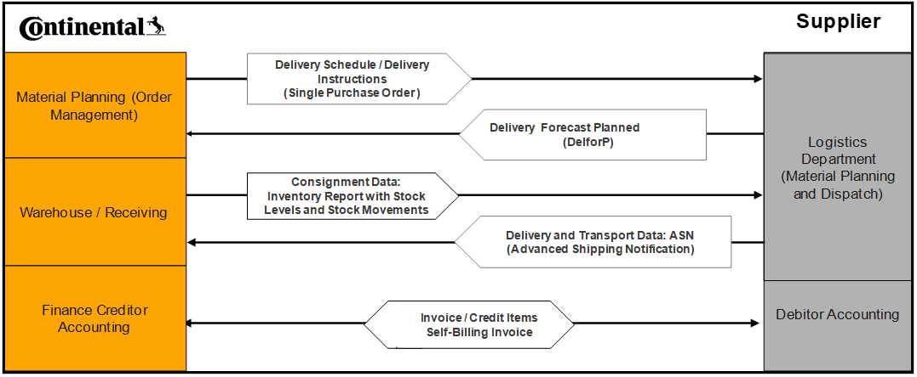

Figure 3: Possible EDI transmissions between Continental and Supplier

### 2.2.2 Setting up an EDI connection with Supplier

The implementation of each EDI connection has to be coordinated with the responsible EDI department of each Continental location. Usually the ordering Continental location contacts the supplier and initiates the EDI implementation. However, suppliers can initiate the implementation as well by contacting Continental plant SCM by themselves.

Both Parties agree on a timeline for the migration of the standard business communication to EDI and clarify first technical settings (EDI parameters and EDI format). Continental prefers certain standards for specific messages. The Supplier checks whether the implementation of EDI according to the specifications of Continental is feasible. If Supplier is not able to implement EDI, then WEB EDI (via SupplyOn) is accepted as alternative process. For details on the implementation process, please refer to section 2.4 ‘WEB EDI via SupplyOn’.

In the course of the implementation, Supplier will receive further technical details on the EDI settings and location specific regulations. Technical details for the message types (e.g. data element, segment, EDI envelope) will be provided during the set-up of the connection and are to be reviewed and tested with the respective Continental location, Continental EDI department, and Supplier case by case before the set-up. In case of any discrepancies in designation of the information used within this communication, both Parties review the discrepancies and cooperate in good faith to solve the issue.

In case testing is necessary, Continental uses test IT-Systems and not the productive IT-Systems in order to avoid impacts on manufacturing processes.

Supplier should adjust system-settings in its IT-System for data processing in order to guarantee complete compatibility with the message format of Continental and to ensure that the messages are processed correctly in its IT-System. Accuracy is imperative in order to maintain the integrity of data exchanged. When failure-free transmission is ensured, the data will be transmitted only by EDI.

### 2.2.3 Monitoring and EDI Processing

Once the connection is set and implemented, Supplier assures the consistency of the IT-System throughout all its processes. Both Parties monitor the information flow in their IT-Systems on a regular basis in order to ensure an accurate communication and complete data transfer. EDI will be considered received by Supplier when the data transmission (EDI or WEB EDI) has been sent successfully from Continental’s ERP-System.

## 2.3 EDI Supported Business Communication and Message Types

According to the Preferred Sourcing Model and EDI format Supplier and Continental exchange certain messages. However, detailed content of the message (e.g. data structure, format, mode or frequency of transmission) may vary from one Continental location to another depending on the agreed (Preferred) Sourcing Model, the Contract Product and systems settings at each ordering Continental location. Therefore, this manual covers what kind of information that is Continental capable to communicate in messages rather than describe details of the EDI format and used structure. For further details please consider our EDI Specifications.

Supplier and Continental exchange currently the following message types:

### 2.3.1 Delivery Schedule

In general, a Delivery Schedule is a communication sent from Continental who is planning to use or consume products of a Supplier which has to plan for the supply of the Contract Products. The message gives the requirements regarding details for short term deliveries and/or medium to long term scheduling. For details and content on Delivery Schedule please refer to ‘CHAPTER 4: Order Management and Planning’. The Delivery Schedule message is sent by EDI and the current Continental company standard format is a GLOBAL DELFOR based on EDIFACT standard (e.g. EDIFACT D.04A). The message might also be referred to as DELINS (Scheduling Agreement Lines) or DELFOR01 (Forecast Delivery Schedule).

### 2.3.2 JIT Schedule

In addition to Delivery Schedule, the Just-in-Time (JIT) Schedule can be also sent to the Supplier to reflect the short-term requirements (2 weeks) on a daily basis. The JIT Schedule message is sent by EDI and the current Continental company standard format is a GLOBAL DELFOR based on EDIFACT standard (e.g. DELJIT). This message supports the JIT process.

### 2.3.3 Inventory Report

An Inventory Report provides information related to consignment stock levels and stock movements. Continental provides this kind of information for consignment processes only. Supplier requires this information in order to plan resupply and to be well informed about stock levels in the consignment warehouse and movements in the consignment inventory. With an Inventory Report Continental informs Supplier about the quantity withdrawn from consignment stock and for which the invoicing process is started (Self-Billing).

The current preferred Continental company standard format is based on EDIFACT INVRPT_13a. Previous INVRPT 97A, EDIFACT INVRPT 99B formats will be phased out with the implementation of the SPIRIT program.

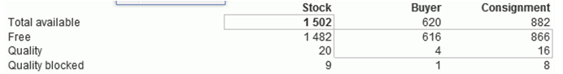The INVRPT includes a unique consumption reference number for each single/aggregated withdrawal out of consignment and other special qualifiers to provide information about consignment stock levels, goods receipt and goods issue message indicating the transfer of ownership to Continental or any corrections thereof.

If Supplier agrees, Continental can include in separate Inventory Report messages on stock levels of free, quality and quality blocked levels of consignment stock, Continental stock and a total thereof - provided Supplier’s IT-System can technically process this information.

Figure 4: Information of stock levels available to Supplier in the event Supplier fully implements Inventory Report Data for VMI.

### 2.3.4 Self-Billing Invoices (SBI)

The purpose of this message is to automate the invoicing process. Currently the preferred Continental standard format is EDIFACT INVOICE_07a. Previous INVOIC 96A, INVOIC 97A will be phased out with the implementation of the SPIRIT program.

Note that Self-billing invoices are subject to applicable law and handled in accordance with applicable accounting regulations in the countries of the business partners.

### 2.3.5 ASN - Advanced Shipping Notification -, ‘Global ASN’ and Delivery and Transport Data

ASN (Advanced Shipping Notification) is a notification of pending deliveries (in transit deliveries), similar to a delivery note or packing slip. Supplier sends the ASN via EDI or other means at the time a delivery is shipped. At Continental the ASN is known as a ‘Global ASN’ and is based on EDIFACT standard - version DESADV 07A. However, alternatively VDA and ANSI standards or ASN input via SupplyOn are accepted as well.

The goal of the ASN is to provide Continental with information about the delivery well in advance of the actual receipt date. It helps to optimize production planning as well as goods receipt processes.

The Continental Global ASN message electronically mirrors the delivery note and enables Supplier (the sender of an ASN) to describe in detail the contents of a shipment. This includes, by way of example, the contents of a shipment, order information, product description, physical characteristics of the goods, or type of packaging.

In case Continental requires the Suppliers to take part in a TMS project, an ASN message becomes mandatory, and Supplier needs to send an ASN. The same applies if a Continental location requires an ASN transmission for the receiving process.

Suppliers generate the ASN at the time the shipment departs from Supplier's premises and transfers the data to Continental’s IT-System as a ‘Global ASN’ message (1) via classic EDI (EDIFACT, VDA, ANSI, ANFAVEA), (2) via csv upload in SupplyOn, or (3) via manual input in SupplyOn. In case Supplier sends the ASN via SupplyOn, Supplier has to take into account that the SupplyOn ASN profile is prescribed by Continental locations.

The ASN data are automatically imported into Continental´s ERP-Systems where data is processed according to the requirements of each Continental location. The Supplier has to ensure the usage of single line items when posting the ASN, as multiple line items cannot be processed in most of the Continental plants. Single line item means that one ASN/delivery note number is created for each single part number and not for multiple part numbers. An additional requirement is that the ASN/delivery note number has to be unique. For TMS, especially for all deliveries Continental pays for, pre-ASN (day before delivery) is required (electronic pickup advice).

Suppliers who need to test the EDI exchange of ASNs with Continental use Continental's test ERP-Systems and not the productive ERP-Systems in order to avoid an impact on our production planning. In case ASN data interchange is newly implemented, testing is mandatory, and for this it is common practice that Supplier sends a test message to each Continental location first.

For further details regarding the mandatory contents of a ‘Global ASN’ please refer to our ‘DESADV Guideline 07A’:   
https://www.continental-automotive.com/en-gl/Organization/Company/Supplier-Information/downloads/Global-ASN-Global-DESADV-Guideline-published-versi.aspx

## 2.3.6 DELFORP (Delivery Forecast Planned)

## DELFORP (Delivery Forecast Planned) is the supplier EDI response to Continental mid and long term EDI DELFOR releases and provides the possibility for supplier to confirm our EDI demands or to confirm alternative dates and quantities. DELFORP messages will be sent on the same technical interface than the DELFOR messages to the supplier. The goal of DELFORP transmissions is to get a better transparency for both parties, suppliers as well as Continental, for mid-term and long-term planning. It supports the activities of Supplier Capacity Update and Demand Management and is an instrument to prevent upcoming supply shortages.

## 2.4 WEB EDI via SupplyOn

SupplyOn is a web-based platform for cross-company communications for companies within the automotive and manufacturing industry. SCM requires its suppliers to use the SupplyOn Performance Monitor and if applicable WEB EDI and Document Manager.

If the Supplier, for various reasons (i.e. in case the necessary technical infrastructure is not available), is not able to implement EDI, then WEB EDI (via SupplyOn) is accepted as alternative process. Usually suppliers who do not have an EDI interface use SupplyOn WEB EDI.

The difference between EDI and WEB EDI is simply exchanging EDI messages via an internet platform. With the WEB EDI service of SupplyOn, all regular message types can be exchanged, however messages profiles are prescribed and can vary between Continental locations. Supplier can view, print or download these EDI messages transmitted to the SupplyOn platform by Continental via a web-based frontend application.

For the registration of the WEB EDI service Supplier shall contact SupplyOn and both Parties conclude a contract in good faith. After this, the necessary adjustments of SCM processes and changes in system-settings by and between Continental and Supplier are initiated, implemented and tested. Each single routing between Continental location and Supplier has to be done separately in Continental's IT-System, and Supplier will be contacted by the individual Continental location.

Supplier receives further details for the registration process either by the ordering Continental location or via SupplyOn Customer Service. SupplyOn provides training for WEB EDI separately. This is not in the responsibility of Continental.

# Chapter 3: Preferred Sourcing Models (PSM)

Continental strives for lean SCM processes. This means reduced complexity, response times and optimization of inventory. Preferably Continental combines this with consignment or just-in-time processes. Continental designates these inbound strategies as 'Preferred Sourcing Model' or short 'PSM'.

The ‘Preferred Sourcing Model’ defines the SCM concept including the format, content and type of EDI message, stocking location, ownership, delivery frequency and the responsibility for inventory management.

Following Preferred Sourcing Model are possible:

* Customer Managed Inventory (CMI) consignment,
* Vendor Managed Inventory (VMI) consignment or
* Just in Time (JIT).

The Preferred Sourcing Model is chosen by each Continental location in mutual agreement with the Supplier.

For reference and for better understanding enclosed section describes the main characteristics of Preferred Sourcing Models.

## 3.1 CMI - Customer Managed Inventory consignment warehouse

CMI is a consignment process in which Continental as the customer to Supplier manages the material planning in terms of restocking and the Supplier resupplies the Contract Products as indicated in a Delivery Schedule to a location close to or at Continental premises.

Figure 5: Basic principle of CMI consignment warehouse



Continental is entitled to draw the Contract Products from the warehouse in the ordinary course of business. When Continental draws Contract Products from the warehouse, a contract of sale and purchase is concluded based on the presently effective prices and according to the conditions agreed. As a part of the consignment process, Supplier agrees that title to and ownership in the Contract Product together with risk of loss for the Contract Product shall pass to Continental only upon withdrawal of Contract Product from the consignment storage location. Continental withdraws the Contract Product as needed according to production demand. Nonetheless, the Supplier delivers the Contract Product in accordance to Continental requirements.

Supplier will receive via EDI messages of Delivery Schedules and Inventory Reports (including consignment stock level and movements). Note that quantities in the Delivery Schedules are in the case of CMI net requirements. Net requirements are lot-sized and offset with planning logics as a result of applying gross requirements against current stock level, scheduled receipts and safety stock.

Suppliers can use this information and the consignment inventory to optimize its supply chain processes and provide the necessary flexibility within the lead-time. With this Supplier has more flexibility in arranging shipments, in case of CMI an extended window for early or late delivery for SCM Supplier Evaluation. This is described in detail in Chapter 6: ‘SCM Evaluation Processes’ in this Section II.

Details and further requirements for CMI consignment process are agreed between the Parties in the respective CMI contract and during the implementation of the CMI inventory.

## 3.2 VMI - Vendor Managed Inventory Consignment Warehouse

The basic idea of VMI consignment process is to give suppliers the responsibility for inventory management. Thus, VMI is a consignment process in which the Supplier is free to make his own decision regarding the delivery date, frequency, and quantity as long as Supplier maintains the inventory level required by Continental. Continental defines a minimum and maximum stock level, transmits gross demands in the Delivery Schedule and the inventory levels with the Inventory Report. Based on this data Supplier resupplies Continental. In addition, Supplier obtains a notification for the restocked inventory (e.g. proof of delivery (POD) by the forwarder or at latest with the Inventory Report) when the Contract Product is stored at a designated place, which is normally close to or within a Continental production site.

As a part of the consignment process, Supplier agrees that title to and ownership in the Contract Product together with risk of loss for the Contract Product shall pass to Continental only upon withdrawal of Contract Product from the consignment stock. Continental is entitled to draw the Contract Products from the warehouse in the ordinary course of business. When Continental draws Contract Products from the warehouse, a contract of sale and purchase is concluded based on the presently effective prices and according to the conditions agreed. The Supplier receives a notice of the drawn quantity - usually with the Inventory or Movement Report - and in case of SBI the Supplier is informed about payments to be received according to withdrawn quantities and payment terms.

Figure 6: Basic principle of VMI

Continental will provide the Supplier the following information concerning inventory and requirements:

The Supplier will receive via EDI messages of Delivery Schedules and Inventory Information. Note that quantities in the Delivery Schedules are in the case of VMI gross requirements (Continental production requirements). This means that the quantities cited do not consider any stock levels or have undergone any lot sizing, and it is the Supplier which manages the inventory and is responsible to ensure resupply. In this process gross requirements do not include any planning times or fences.

In addition to Delivery Schedules Supplier will receive EDI messages called Inventory Reports. The Inventory Reports inform the Suppliers about inventory levels of the consignment stock (free, quality and blocked) and information about movements in consignment inventory (receipts and pulls). According to this information the Supplier keeps the level/range of inventory within the agreed limits at all times to ensure a stable supply. The Supplier plans resupply according to the actual and to the projected consumption and only ship the quantity of Contract Products into consignment that will maintain the consignment stock below the maximum level and assure on-time shipment, so that inventory will not fall below the minimum level.

The min-/max-level of inventory is calculated based on projected requirements for a certain minimum and maximum period of time and may be designated as range of coverage (e.g. two weeks for minimum and four weeks for maximum material coverage). Supplier can calculate a reference level by multiplying the averaged daily requirements (based on the forecasted gross requirement in the Delivery Schedule for the next 90 days including backlog) and the agreed minimum and maximum range of coverage in calendar days.

Continental and Supplier will review technical details (e.g. exact data content of the messages and frequency of data) during the setup of the Preferred Sourcing Model and testing of the connection. This is necessary in order to ensure correct processing of information and interpretation.

Before the implementation, the Parties agree on specifics in an Individual Agreement for Vendor Managed Inventory consignment.

## 3.3 JIT - Just in Time

JIT is a demand driven sourcing model with a limited inventory coverage range of maximum 2.5 days at the Continental location and high frequency deliveries (at least three times per week) relying on pull signals (e.g. Kanban) between different points (e.g. warehouse or production line). No frozen horizon is allowed.

It requires synchronization of delivery and production in order to optimize supply chain costs and inventories. The concept of synchronized supply aims to reduce the stocks in the supply chain up to the quantity necessary for the supply of Continental production. A zero-error supply chain process is of the essence for JIT.

The Supplier receives in addition to a Delivery Schedule a call-off from the ordering Continental plant, if required or applicable.

Call-off means schedule lines within a limited period of time as a result of pull process. The call-off replaces information in the Delivery Schedule / Forecast Information for the limited period of time. The call-off is decisive for delivery and takes precedence over the Delivery Schedule, and the Supplier should use the Delivery Schedule to plan its production accordingly. The mode of communication of the call-off (e.g. EDI, WEB EDI, E-Kanban, mail) can vary and is agreed between the Parties during the set-up of the concept.



Figure 7: Basic principle of Just in Time

# Chapter 4: Order Management and Planning

It is the Supplier’s responsibility to arrange own supply chain processes in order to ensure supply and delivery of Contract Products.

The following section should help Supplier to arrange its planning processes accordingly, as it describes processes and communications (exchange of information) between Continental and Supplier concerning material planning and monitoring deliveries. This includes frequently used designations, techniques and activities, which Continental expects from Supplier.

## 4.1 Delivery Schedule Processing

Delivery Schedules are generated demand-driven within Continental’s ERP-System according to the Sourcing Model and sent to Supplier.

A Delivery Schedule informs Supplier about current and forecasted estimates of Continental´s Contract Products demand and contains multiple schedule lines up to 24 months forecast, together with the required Continental receipt date (date the Contract Product shall arrive at Continental) and quantities of Contract Products at the Continental delivery address (point of consumption). The Delivery Schedule instructs the Supplier to deliver a specified quantity of Contract Products to a particular Continental location by a specified date and time (Continental will order based on minimum packing units agreed). The Supplier shall use the information to plan deliveries to Continental locations according to the dates and quantities indicated in the Delivery Schedule.  
A transmitted Material and Production Release expresses the obligation of Continental to reimburse specific raw material, finished Contract Products or its sub-assemblies in case Continental changes Delivery Schedules within release period without having scheduled corresponding future requirements or Continental cancels for its own convenience. It applies up to the amount of the cancelled cumulative quantity in the release period for which Supplier can prove it is exclusively used or ordered for Continental and can´t be utilized otherwise.

Delivery Schedules are valid until replaced by the next release of the Delivery Schedule. The next release of a Delivery Schedule for a Contract Product replaces the preceding ones completely. The last received valid Delivery Schedule is decisive for delivery.   
Any supplementary agreements and changes made verbally (e.g. by telephone) must be confirmed by both Parties in writing to be binding.  
If the layout and/or content of the transmitted Delivery Schedules is not self-explanatory to Supplier, the Supplier must contact the ordering Continental location without undue delay in case of doubt (e.g. calculation and interpretation of cumulative quantities).

## 4.2 Delivery Schedule Types

The following provisions explain the general format of a Delivery Schedule message depending on the transmission mode and the used designation. Further information on the data contained in a Delivery Schedule will be provided in form of a guideline (e.g. specification for ‘Global ASN’) during the set-up of a connection.

The IT-System from the Supplier must be able to process the data in order to guarantee complete compatibility with the message format and with Continental’s commercial interpretation of designations.

### 4.2.1 Delivery Schedules – Differences in Sourcing Models

Supplier understands that quantities cited in Delivery Schedule for VMI are ‘**gross requirements’** and **‘net requirements**’ in case of CMI consignment process, JIT or ship-to-stock.

Enclosed table summarizes the main commercial differences associated:

| Sourcing Model | Communicated Message Type | Details |
| --- | --- | --- |
| STS  Ship-to-Stock | Delivery Schedule | The Delivery Schedule received by Supplier for ship-to-stock parts is binding on Supplier, and Supplier has to adhere to the dates (+/-1day) and quantities, rather than being merely interpreted as forecast.  For this Continental sets appropriate parameters and planning logics in its ERP-System to plan resupply. Quantities cited in Delivery Schedule and their due dates are based on ‘net requirements’.  Ship-to-Stock is **not a Preferred Sourcing Model** and shall be used only outside of series and volume production. |
| CMI | Delivery Schedule  Inventory Report | CMI is a consignment process in which Continental as the Customer manages the material planning in terms of restocking and the Supplier has to supply Continental as indicated in the Delivery Schedule.  However, as Supplier receives additional information on consignment stock levels and movement reports Supplier has more flexibility in arranging shipments.  Quantities cited in Delivery Schedule and their due dates are based on ‘net requirements’.  For further details on this ‘Preferred Sourcing Model’ please refer to section ‘3.1 CMI – Customer Managed Warehouse Consignment Process’. |
| VMI | Delivery Schedule  Inventory Report | With VMI, the Supplier interprets the Delivery Schedule as merely forecast information and non-binding on Continental. Supplier assumes complete responsibility for resupply for defined Contract Products and receives the Delivery Schedule along with daily or weekly Inventory Reports containing information about the stock level and withdrawals.  Based on this information, Supplier has to ensure resupply in accordance with the agreed upper and lower range of coverage in calendar days (these limits are not transmitted in an EDI message).  Supplier understands that current and forecasting estimates in Delivery Schedules are ‘production demand’, which are also referred to as ‘gross requirements’.  For further details on this ‘Preferred Sourcing Model’, please refer to ‘3.2 VMI – Vendor Managed Warehouse Consignment Process’. |
| JIT | Delivery Schedule  JIT call-off | Supplier receives a Delivery Schedule, which Supplier uses merely for planning purpose. Additionally, Supplier receives a JIT call-off, which replaces the Delivery Schedule/Forecast Release for a limited period of time as agreed mutually and in good faith with the ordering Continental location.  The call-off is decisive for delivery and takes precedence.  For further details on this ‘Preferred Sourcing Model’ please refer to section ‘3.3 JIT - Just in time’ in this Section II. |

Figure 8: Sourcing Models

# Chapter 5: Supply Chain non-conformities

Non-conformity of packaging, identification, delivery documents or any non-compliance of delivery instructions can lead to a Supply Chain complaint initiated by the plant where deviation has been identified.

A Supply Chain complaint is a Supply Chain-related disturbance caused by Supplier influencing Continental or a Continental customer. Notification of a Supply Chain complaint will be done through official letter, same as a quality incident, and requires a confirmation and an open 8D-report in line with the stipulations of Continentals General Quality Agreement.

Causes that fall within the Supply Chain claims complaints include, without limitation:

**Packaging**

Damaged Packaging / Transport damage

Contaminated packaging

Packaging not according to specification (PSDS)

Packaging with mixed load

**Identification**

Missing label

Label not readable

Label not according to specification

Missing ASN

ASN not according to specification

Incorrect material

Incorrect quantity

Label no at correct position

**Delivery documents**

Missing delivery documents

Delivery document not according to specification

**Delivery**

Non-compliance delivery instructions, independent of an acceptance of a delayed delivery

Material shortages

Incorrect order code   
Incorrect data code  
Shelf-life exceeded

# Chapter 6: SCM Evaluation Processes

Continental and Supplier ensure the quality of supply chain processes and continuously improve. In order to meet this challenge, the following tools and processes are standard at Continental Automotive Technologies:

**Supplier Evaluation at Continental**

Continental evaluates the quality and Supply Chain performance of its Suppliers on a monthly basis using standardized evaluation criteria. The results are incorporated in the annual evaluation of strategic suppliers to Continental called ‘Basic Annual Supplier Evaluation’ (BASE). Details on Supply Chain Supplier evaluation are provided in section ‘6.1 SUPPLIER EVALUATION AT CONTINENTAL’.

**MMOG/LE NP**

Continental evaluates and optimizes its Supply Chain processes based on the MMOG/LE NP (Material Management Operations Guideline / Logistics Evaluation New Platform) in order to ensure high supply chain performance towards its customers now and in the future. Continental requests also its Suppliers to evaluate their supply chain processes based on the MMOG/LE NP and provide the result to Continental Automotive Technologies.

For reference, and for better understanding of the MMOG/LE NP, an overview is provided in ‘6.2.4 SELF ASSESSMENT (MMOG/LE NP) OF SCM PROCESSES’. However, information on the MMOG/LE NP and further instructions are available with the questionnaire itself.

**Supplier Classification with BASE**

Within BASE (Basic Annual Supplier Evaluation), the performance of strategic suppliers in the previous calendar year as well as its strategic potential for the coming year is evaluated with focus on purchasing, quality, SCM and technology elements. BASE is an important tool in the strategic supplier management process at Continental, and its results influence sourcing decisions, serve for supplier selection and supplier classification.

**SCM Audits at Supplier’s premises:**Upon request and Supplier approval, Continental conducts routine SCM audits at Suppliers’ premises to verify and assess the SCM systems, including compliance with all Continental SCM requirements.

## 6.1 Supplier Evaluation at Continental

Continental evaluates the Supply Chain performance of its Suppliers on a monthly basis using standardized evaluation criteria. These are: the Delivery Capability, the degree of implementation of Preferred Sourcing Models (PSM Rate), feedback of the Self-Assessment MMOG/LE NP (if any) and a choice of Service Criteria. Details on the calculation of each Supply Chain criterion are provided in ‘6.2 SCM SUPPLIER EVALUATION CRITERIA’. The target is to achieve 100% in each criterion. Each criterion is considered with a certain weight according to its importance when calculating the total result.

The monthly Supply Chain performance is reported thru the SupplyOn Performance Monitor to Supplier once per month.

For strategic suppliers the monthly result is incorporated in the annual evaluation of strategic suppliers called ‘Basic Annual Supplier Evaluation’ (BASE). This yearly evaluation is also communicated to Supplier thru the SupplyOn Performance Monitor.

Depending on the outcome of the evaluation, Supplier is expected to define and implement appropriate corrective actions. If the SCM Performance fails to meet the committed goals, Supplier implements immediate corrective actions and provides a get-well plan upon request. The plan should include actions of how to solve and how to avoid these sorts of incidents in the future. Deviation in actual performance may result in corrective actions to bring Supplier’s SCM Performance in line with Continental expectations.

Figure 9: SCM Performance

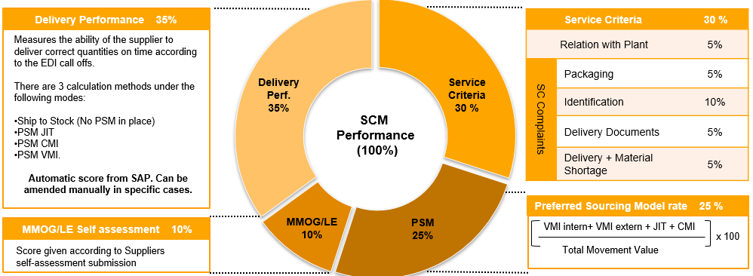

## 6.2 SCM Supplier Evaluation Criteria

Continental evaluates the Supply Chain performance of suppliers based on criteria, which are standardized. For better understanding of the evaluation, the calculation of each criterion is described below.

### 6.2.1 Delivery Capability

The criterion ‘Delivery Capability’ measures Suppliers’ ability to deliver the right quantity of the Contract Product on the date specified in the Delivery Schedule or in case of VMI the capability of Suppliers to keep the stock level for Contract Products within the agreed min/ max inventory limits. This approach is standard practice within the automotive industry.

Within Continental, the calculation of delivery capability is standardized and backed by an IT-System: when goods receipt is posted in Continental’s ERP System, instantly the delivery is evaluated with respect to date and quantity requested. Each and any goods receipt is evaluated on Contract Product basis vs. the information in the Delivery Schedule. The individual measurements are aggregated for each Continental location and the Continental group each month and then represent a percentage evaluation of Supplier’s monthly delivery capability.

#### ****- Calculation of Delivery Capability for Ship-to-Stock****

In case of ship-to-stock sourcing model the correct quantity of Contract Product has to arrive at Continental on the date specified in the Delivery Schedule. The delivery capability measures the deviation in time to the date the quantity of the Contract Product must be received by Continental. These dates are indicated in the Delivery Schedule together with the required quantity.

Each delivery which is received ± 1 day from the requested delivery date and matches exactly the requested delivery quantity is valued with 100%. Early or late deliveries receive a proportional penalty deduction. In the event Continental receives a delivery too early this is subject to lower reductions as this represents a lower risk for Continental. Late deliveries are a risk! Therefore, late deliveries are evaluated with a higher proportional penalty deduction.

In the event the quantity differs to the requested quantity, this difference is taken into account proportional to the quantity falling short or being delivered in excess. An over delivered quantity is calculated towards the next delivery item and results in a delivery that is too early.

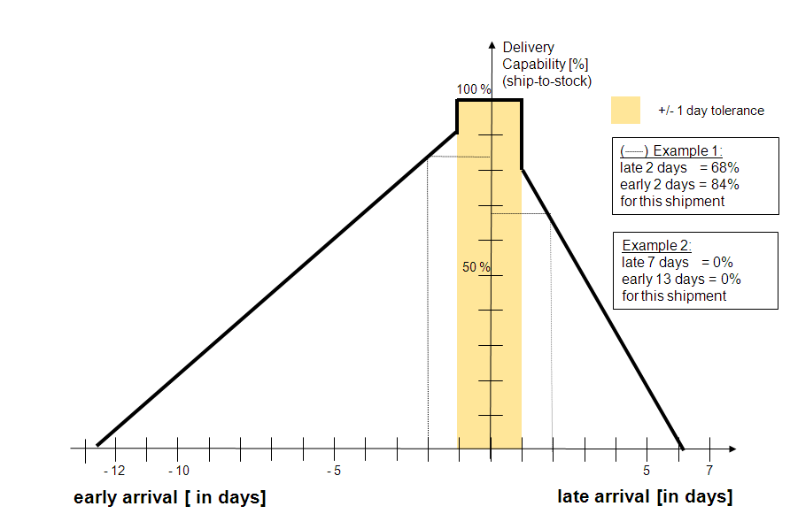The figure enclosed shows in:

**Example 1**: How the delivery capability is measured for a shipment that arrives two days late (68%) or two days early (84%) vs. the request date.

**Example 2**: In the event, a delivery arrives 7 days late or 13 days too early the shipment is evaluated with 0%. These are the upper or lower limits, taking into account that either storage capacity or resupply of Continental is at high risk.

**Example 3**: Continental receives 2.500pcs of A2Cxxx on 05.02, but only 2.200pcs were requested for 05.02, the delivery is evaluated as follows:

Supplier receives 100% for the delivery of 2.200pcs on 05.02. The over delivered 300pcs are evaluated for the next schedule line due on 07.02. The next delivery of 300pcs is due on 07.02. The 300pcs are delivered 2   
 days too early and therefore, receive a reduction of 16%. The target   
 achievement for the delivery on 07.02 is 84%.

Figure 10: Calculation of Ship to Stock Delivery Capability

#### *- Calculation of Delivery Capability in case of CMI*

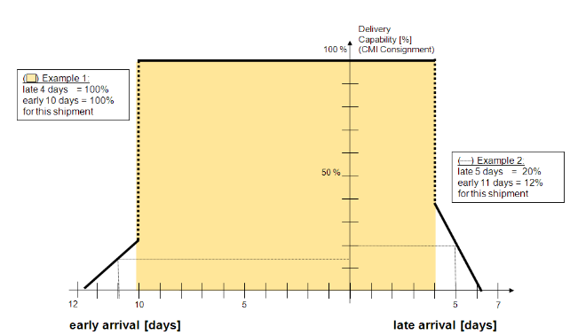In case of CMI deliveries, only receipts within tolerance -10/+4 days from the requested delivery date get 100% evaluation

(Example 1, Figure 11). Beyond the tolerance range, early or late deliveries receive a proportional penalty deduction (Example 2, Figure 11). In comparison with ship-to-stock model, a higher tolerance is allowed as Supplier receives via EDI information about stock levels. As a part of CMI consignment process Continental manages the material planning in terms of restocking and the Supplier resupplies the Contract Products as indicated in a Delivery Schedule. However, Supplier can optimize its delivery frequencies and deliver earlier or later as indicated in the Delivery Schedule since Supplier is well informed of the stock levels. However, due to storage capacity, Continental limits this tolerance on 10 days earlier; else, the storage capacity is exceeded.

Figure 11: Calculation of delivery capability for CMI

#### - Calculation of Delivery Capability in case of VMI

In the case of VMI, the delivery capability measures the compliance of the Supplier to keep the stock of Contract Products within the agreed minimum (min) and maximum (max) inventory limits.

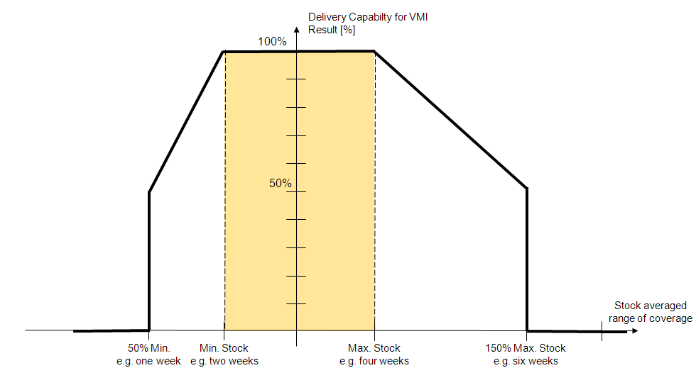The limits are documented in Individual Agreements for VMI. The min. inventory level is defined as the required stock in days/weeks based on the current averaged production demand. The max inventory level is defined as maximum inventories in stock in days/weeks based on the current production demand.

Continental's IT-System calculates the min/max levels once daily and checks the current stock vs. the agreed levels. Stock levels within the defined limits get 100% evaluation, deviations from the defined min/max limits leads to a linear-proportional deduction up to 0%. If the current stock level falls 50% below the min limit or exceeds 150% of the stretched max limit the SCM Performance is evaluated as 0%. The monthly result for delivery capability is an aggregated figure of these daily measurements.

Figure 12: Calculation for delivery capability in case of VMI

### 6.2.2 PSM Rate

Continental requests its Suppliers to deliver the Contract Product according to the Preferred Sourcing Model decided by the Continental location and agreed in Individual Agreements. The PSM Rate measures the implementation degree of consignment or any other Preferred Sourcing Model.

The PSM Rate is defined as the ratio of goods receipt value for Preferred Sourcing Models to the goods receipt value total on location, Contract Product, and Supplier level.

The Supplier receives an evaluation in this criterion according to the PSM Rate (e.g. a PSM Rate of 50% leads to a 50% score in the Supply Chain evaluation for PSM implementation). In case no PSM is implemented, the Supplier receives a zero evaluation for PSM Rate. The PSM-Rate is not calculated on a year-to-date basis but covers the period of one month.

The PSM Rate is calculated as follows:

PSM Rate = goods receipt value for Preferred Sourcing Models divided by goods receipt value total.

### 6.2.3 Supply Chain Complaints

The term ‘Supply Chain complaints’ describes a couple of predefined criteria that Continental uses to evaluate support and service of Supplier in day-to-day business.

Score for ‘Relation with Plant’ is an appreciation from each individual Continental location regarding general collaboration.

Scores for ‘Packaging’, ‘Identification’, ‘Delivery Documents’ and ‘Delivery + Material Shortage’ are based on Supply Chain incidents. Additional detailed information on Supply Chain incidents for each Service Criterion can be found in SupplyOn Performance Monitor.   
Score for each Service Criterion is 100% by default. One Supply Chain incident means 0% scoring in the corresponding Service Criterion at the affected Continental Location only.

Global score of each Service Criterion remains an automatic average of all Continental Locations scores.

Depending to the Plant, Supply Chain complaints can be raised to notify the Supply Chain incidents to Supplier. Supply Chain complaints can be transmitted to Supplier via e-mail or via Problem Solver Module in SupplyOn and are relating to standardized Supply Chain incidents. They fasten the failure analysis and implementation of effective measures.

### 6.2.4 Self-Assessment (MMOG/LE NP) of SCM Processes

The Material Management Operations Guideline / Logistics Evaluation New Platform (MMOG/LE NP ) is the standard for evaluating supply chain processes in the automotive industry. It is a tool that enables a comprehensive self-evaluation and which is used by all OEM’s and their suppliers for internal assessments, organization benchmarking, and improving supply chain performance.

Continental requests its suppliers to evaluate their supply chain processes based on the MMOG/LE NP and to provide the result to Continental Automotive Technologies. The MMOG/LE NP questionnaire is available on the web-based platform that can be found on the AIAG or ODETTE website (www.aiag.org or www.odette.org) and requires a fee. Suppliers to Continental are requested to purchase the license, fill in the full English version of the questionnaire and send it afterwards to Continental.

In case the Supplier does not submit the MMOG/LE NP, the Supplier understands and accepts a penalty deduction in the supplier evaluation. If the MMOG/LE NP is not provided in due time, Supplier has to accept reductions in the overall SCM Performance.

Continental introduced a scoring evaluation system, which is based on a qualitative analysis of the self-assessment files. Suppliers should fill-in the current status for each criterion. For each non-compliant criterion the content of the action plan and its target date is checked.

According to the result of such MMOG/LE NP (A-, B- or C-level) Supplier gets a fixed score. Supplier receives at minimum 50% if Supplier provides Continental a MMOG/LE NP – even if it is a C-Performance. This is because Continental honors Supplier’s effort to audit and benchmark their supply chain processes to best practices within the automotive industry.

Continental expects that Supplier uses the result of such evaluation to optimize its supply chain processes in order to ensure high SCM Performance. Moreover, Supplier understands that the Feedback and result is the basis to select suppliers for an improvement process and collaboration meetings. In case of poor results, the Suppliers has to provide Continental an action plan with corrective measures of how to avoid this situation in future.

## 6.3 Supplier Evaluation Reporting

Continental uses the SupplyOn Performance Monitor (PerMo) to communicate the results of the monthly (SCM and Quality) and yearly (BASE) evaluation to its Suppliers.

Note that a registration for SupplyOn and registration for this SupplyOn Service is required. All strategic suppliers to Continental are requested to register to SupplyOn by Continental. Suppliers that are not yet strategic suppliers for Continental can contact their respective purchasing contact or SupplyOn Customer Service for further details. The contact details for SupplyOn Customer Service are available on the Internet by performing an internet search entering 'SupplyOn for Suppliers'.

### 6.3.1 Availability of Data

Continental’s IT-System continuously processes the data for delivery capability or PSM-Rate. However, data to SupplyOn Performance Monitor is transmitted only once a month to the SupplyOn Platform. The monthly Supplier Supply Chain evaluation (designated in SupplyOn Performance Monitor as Operational Evaluation SCM) is viewable in the beginning of each month for the previous month and the last 12 months. Usually it is available every 8th working day on 0:00h (CET, German calendar).

The yearly BASE evaluation is viewable for strategic suppliers in the SupplyOn Performance Monitor at the beginning of the 2nd quarter for the previous calendar year.

### 6.3.2 How to work with SupplyOn Performance Monitor

Within the SupplyOn Performance Monitor application, a manual is available which describes how to read the evaluated criteria. Suppliers can download this information with a click on the phrase ‘Help for customer evaluation system’.

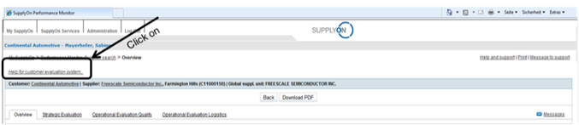

Figure 13: SupplyOn - Help for customer evaluation system

For details of how to work with the SupplyOn Performance Monitor, please contact SupplyOn.

For reference and for better understanding of the Supply Chain evaluation in the SupplyOn Performance Monitor an overview of its set-up, structure and criterions is provided below. However, details on the SupplyOn Performance Monitor and further instructions are available with SupplyOn Customer Service if needed.

### 6.3.3 Summary of the Supplier Performance Evaluation (in SupplyOn designated as Overview)

The overview summarizes the Supplier evaluation of the precedent months, for quality and for SCM. Scrolling down the page the SCM result is available. The SCM Performance is summarized in a radar chart and a ranking of the worst performance in each Supply Chain criteria.

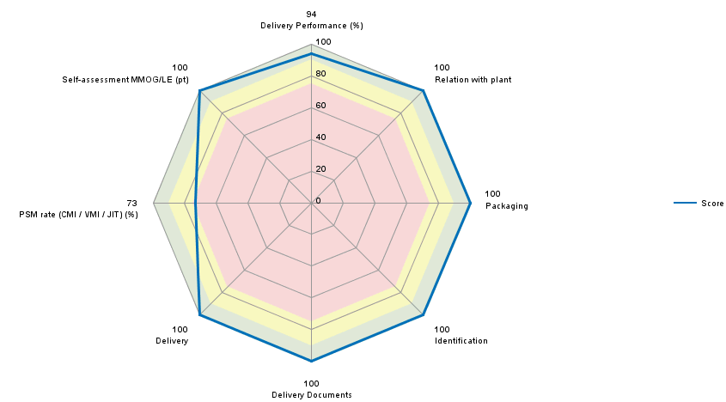

Figure 14 - Radar Chart, Performance Monitor

The radar chart plots the scoring (blue line) of the Supplier in each criteria along a separate axis that starts in the center of the chart (0% achievement) and ends on the outer ring (100% target achievement). With this, strengths and areas for improvement can easily be identified. Example: In the figure enclosed Supplier has high service criteria ratings but improvement is required on the PSM rate (73%). In addition, it is recommended that Supplier improves his delivery performance.

### 6.3.4 Monthly SCM Performance (in SupplyOn designated as Operational Evaluation Supply Chain)

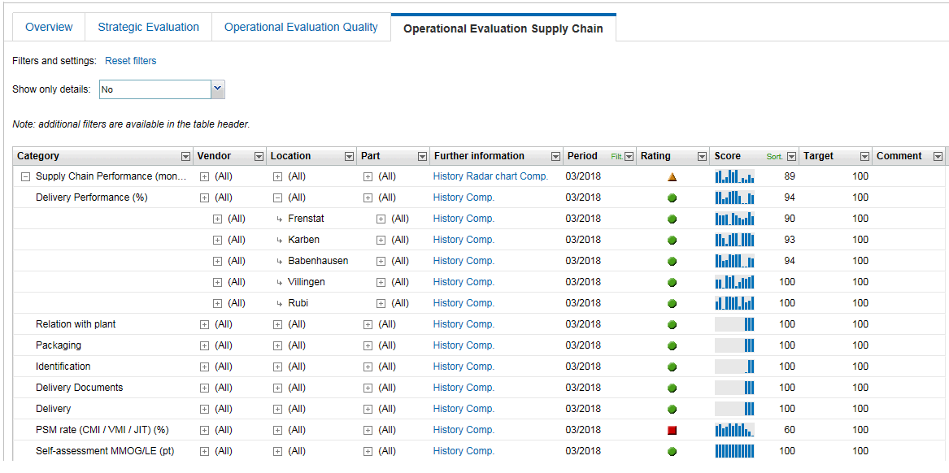

Figure 15 - Example Performance Monitor

With SupplyOn Performance Monitor the results for the SCM Performance (click on ‘Operational Evaluation Supply Chain’) are available on a consolidated level for Continental Automotive Technologies (as a whole), on vendor, location and part level for the previous twelve months (rolling history).

It starts at a consolidated level and can be further drilled down to location (click on ‘Supply Chain performance, All’) and then to the previous 12 months (click on ‘History’). With this information, Supplier can do detailed analysis. Further details on e.g. part number level are available upon request at the respective Continental location contact (if required).

### 6.3.5 BASE for strategic suppliers (designated in SupplyOn as Strategic Evaluation)

The yearly consolidation of these Monthly Supplier Evaluation combined with the strategic potential evaluation are the basis of the BASE evaluation. Goal of the potential evaluation is to measure the supply risk as well as the supplier involvement in Continental new challenges & defined projects. Therefore, potential criteria may be reviewed to be aligned with the Supply Chain Management Strategy.

# Frequently used Definitions and Abbreviations

8D 8 Disciplines

AIAG Automotive Industry Action Group

ANFAVEA Associação Nacional dos Fabricantes de Veículos

ANSI American National Standards Institute

A O SCM Automotive Operations Supply Chain Management

ASN Advanced Shipping Note

BASE Basic Annual Supplier Evaluation

CA Continental Automotive Technologies

CA TST Continental Automotive Technical Standard-Norms

CMI Customer Managed Inventory

CSV Character Separted Values data format

DELFORP Delivery Forecast Planned Delivery

EDI Electronic Data Interchange

EDIFACT International EDI standard (Electronic Data Interchange for Administration, Commerce, and Transport)

ERP Enterprise Resource Planning

GALIA Groupement pour l'Amélioration des Liaisons dans l'Industrie Automobile

GXS Global eXchange Services.

INVRPT Inventory Report

JIT Just In Time

MMOG/LE Materials Management Operations Guideline / Logistics Evaluation

NFO Next Flight Out

OBC On-Board Courier

ODETTE Organization for Data Exchange by Tele Transmission in Europe

OFTP ODETTE File Transfer Protocol

PerMo SupplyOn Performance Monitor

PPAP Production Part Approval Process

PSDS Packaging Specification Data Sheet

PSM Preferred Sourcing Model

SBI Self-Billing Invoices

SCM Automotive Operations Supply Chain Management

SCR Supplier Component Review

SSC Strategic Supplier Contract

STS Ship-to-Stock

SupplyOn Electronic Marketplace for Automotive Suppliers

TMS Transport Management System

TST Technical Standard (norm of Continental Automotive Technologies)

VDA Verband der Automobilindustrie (German Association of the Automotive Industry)

VMI Vendor Managed Inventory

WEB EDI Web based Electronic Data Interchange

YPSA Yearly Pricing and Supply Agreement.

Editor: A O SCM NR SB

Continental Automotive Technologies GmbH